AMAZON SIMPLE QUEUE SERVICE(SQS)

Amazon Simple Queue Service (SQS) is a fully managed message queuing service
used to decouple distributed applications.
It acts as a temporary storage area for messages between applications.
Why Do We Use SQS?
SQS helps solve:
-- application dependency issues
--traffic spikes
--asynchronous processing
-- reliability problems
Use Case : An e-commerce website receives thousands of customer orders.
If the backend database becomes slow or overloaded:
--orders may fail
--users may see errors
-- system may crash
To avoid this, we use Amazon SQS.
Create SQS Queue
Click create queue --- give queue name –
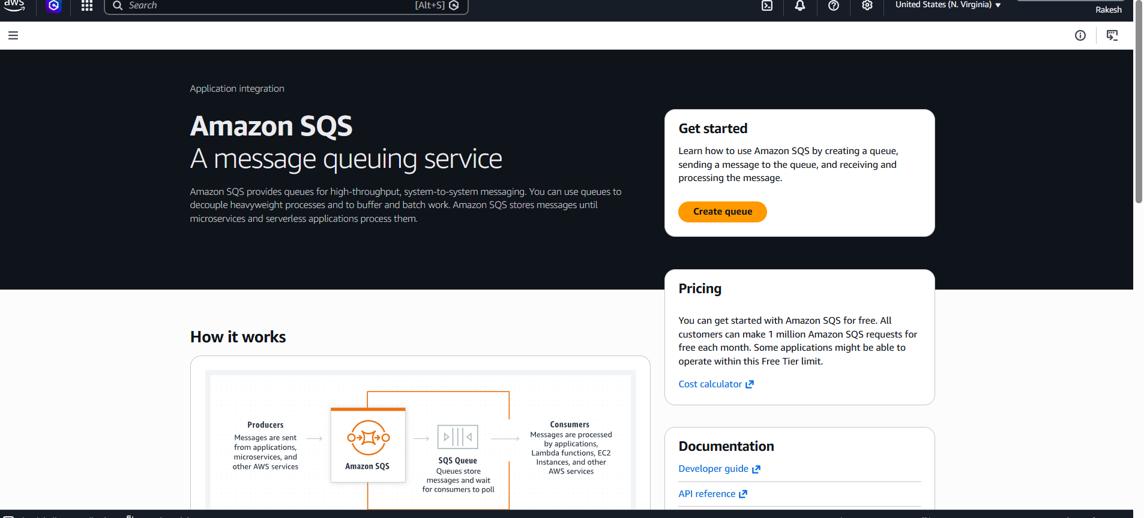
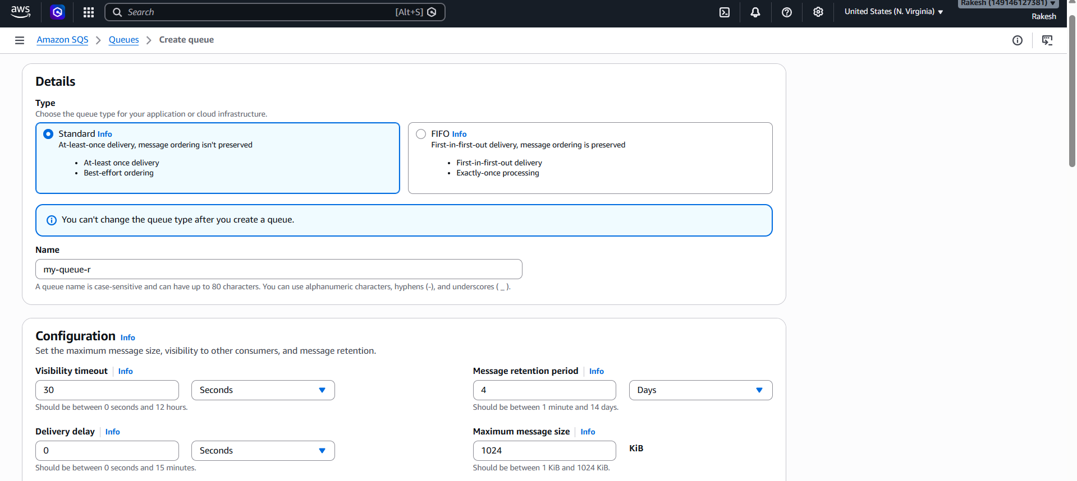
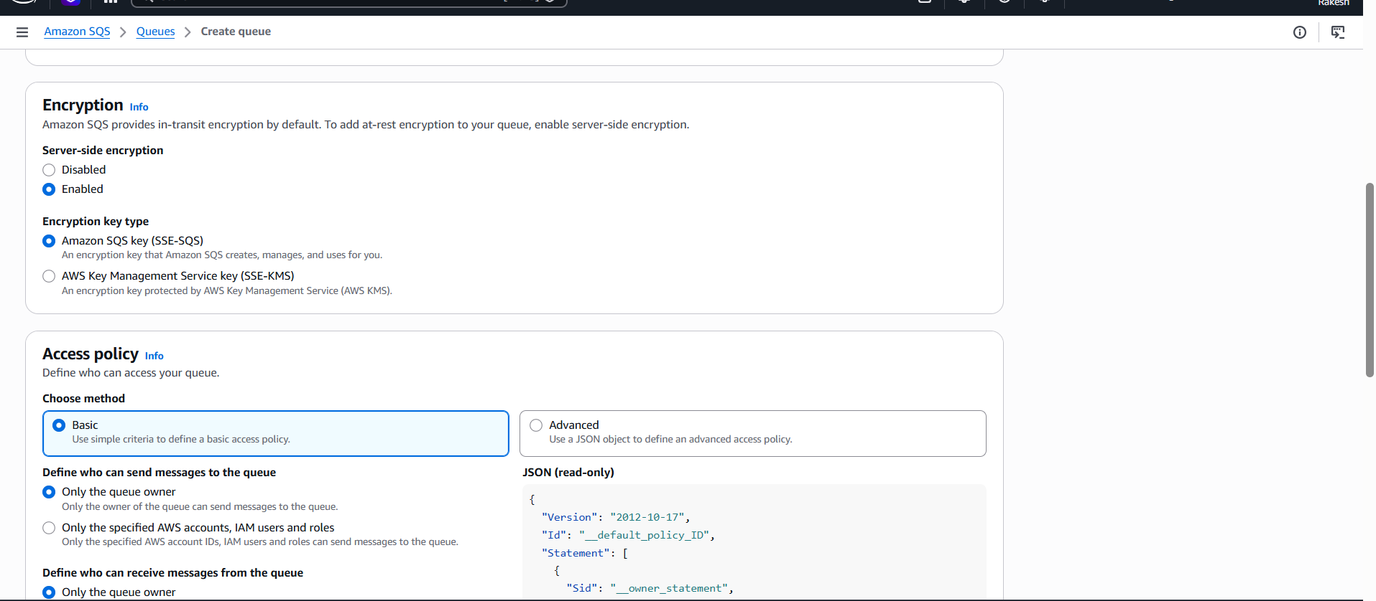
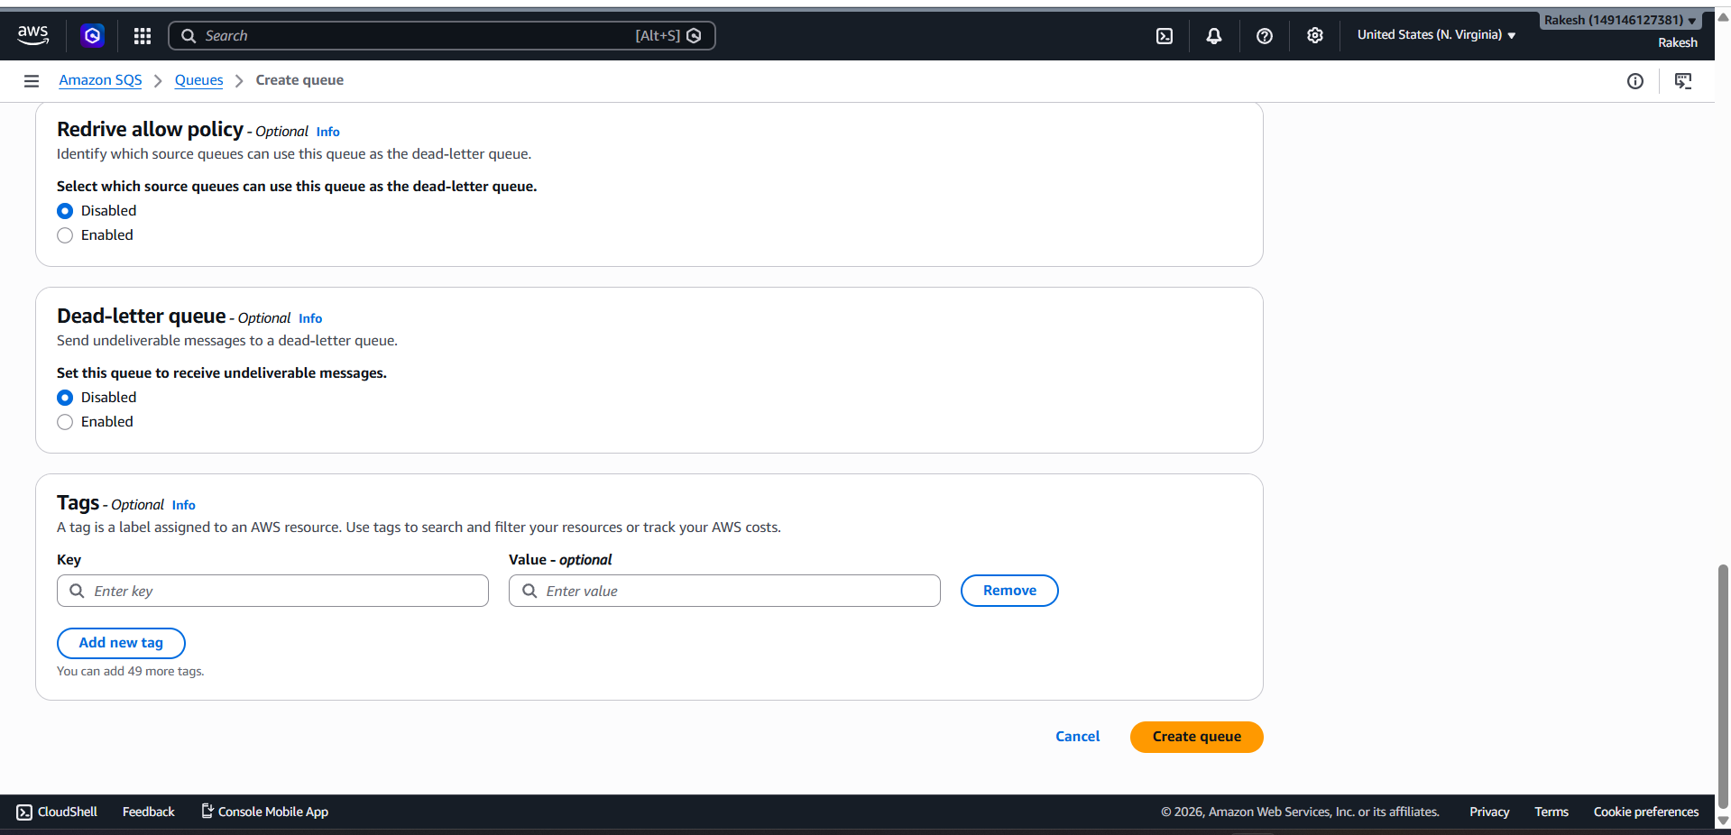
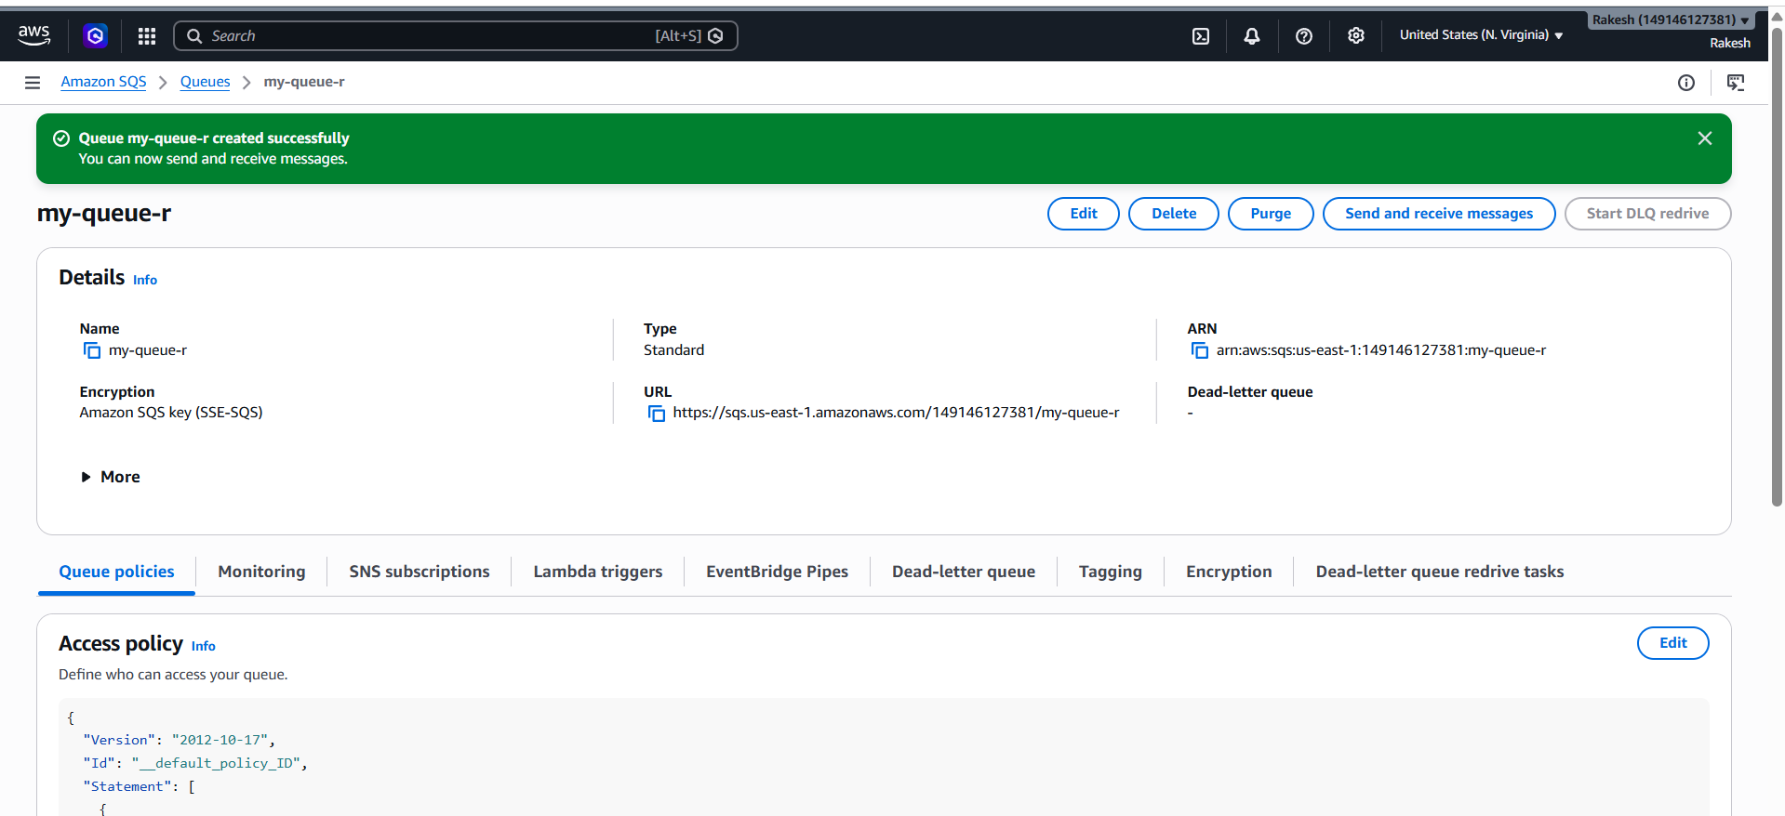
Send Order Message
Click on send and order messages ----write json script in message body---send
Message
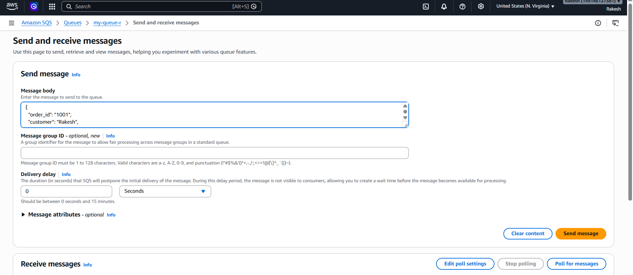

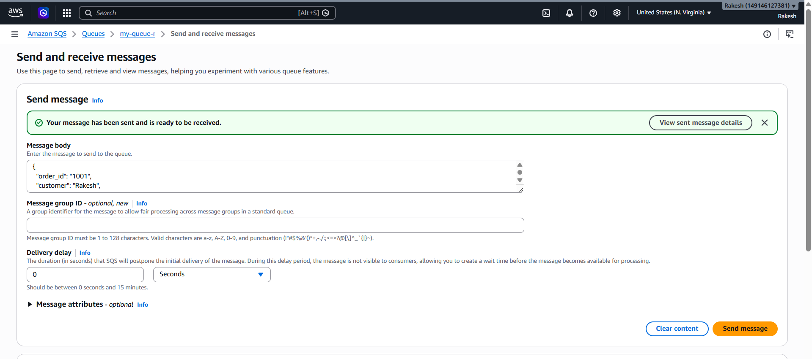
Go to receive messages → click pull for messages
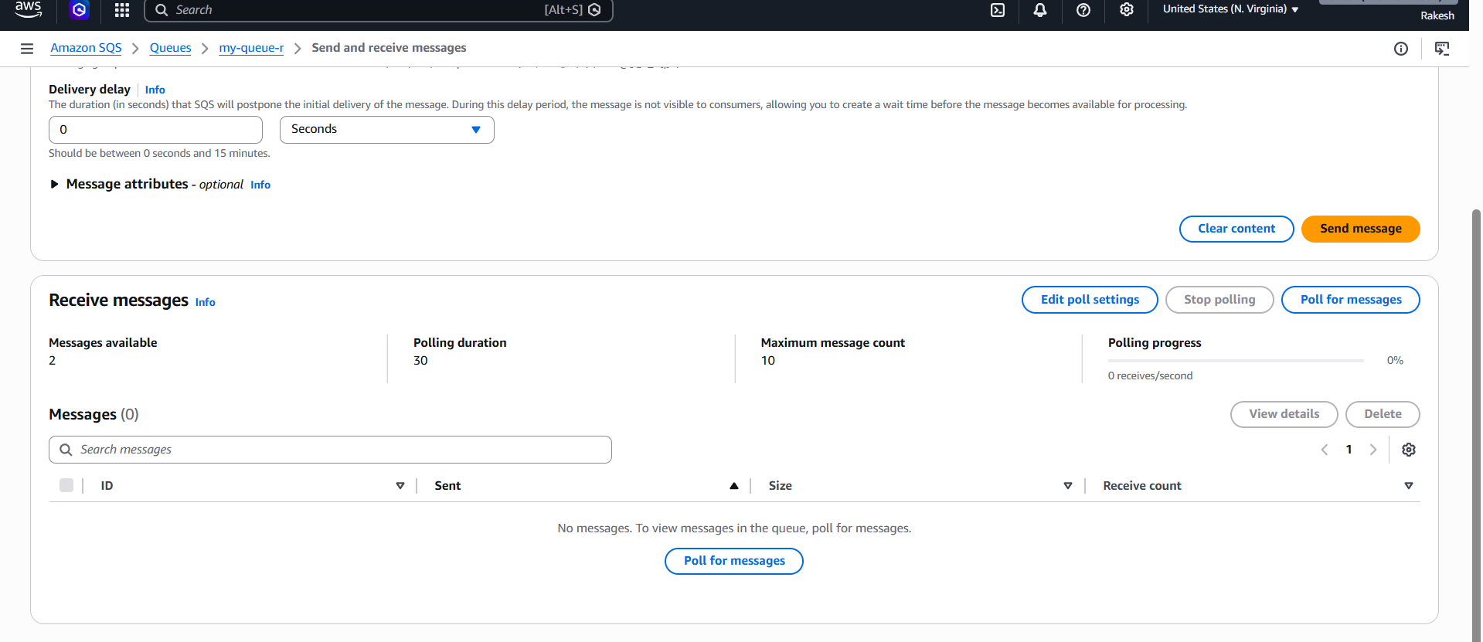
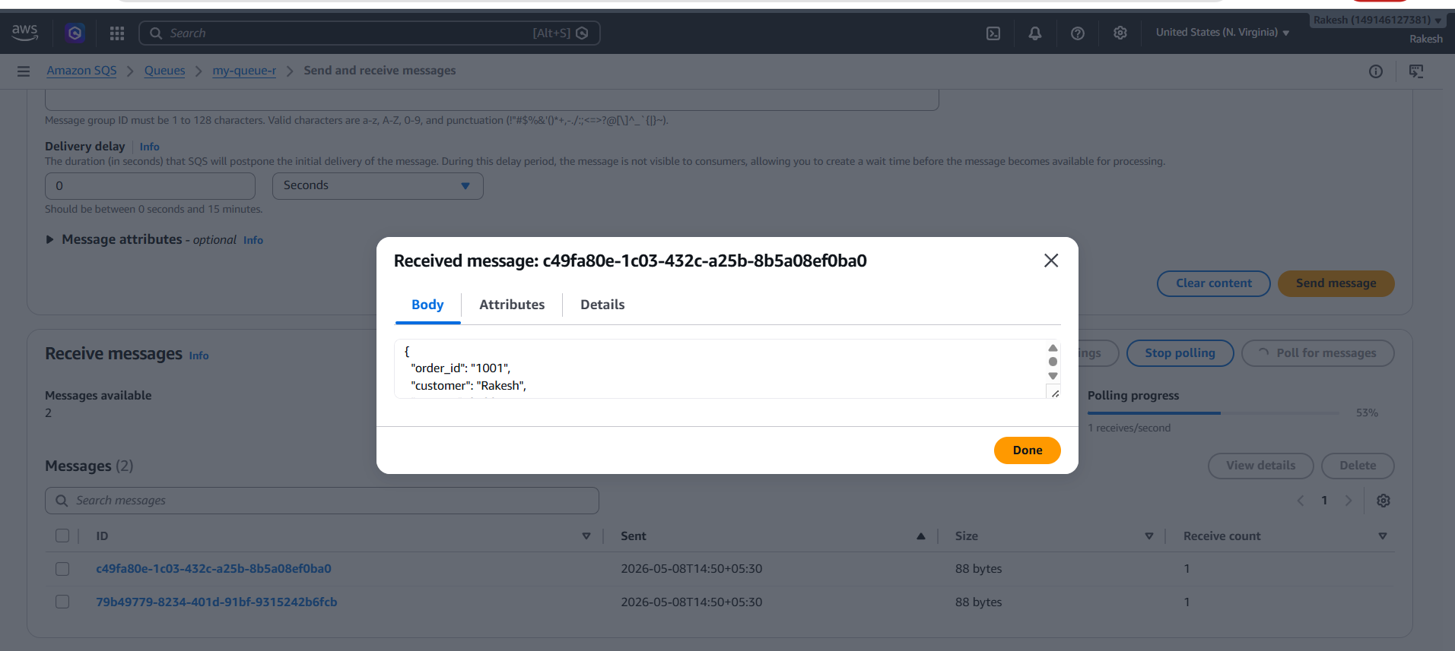
Monitor logs
